Certificate

This is to certify that Amanjyot kaur and research report entitled “WORKING CAPITAL MANAGEMENT IN HCL INFOSYSTEM LTD.” is approved and is acceptable in quality and form.

_______________
Faculty Guide

date:________________
Place: :_______________

DECLARATION

I hereby declare that the project report entitled:

A Research Report on “WORKING CAPITAL MANAGEMENT IN HCL INFOSYSTEM LTD.” submitted in partial fulfillment of the requirement for the degree of BBA, is my original work and not submitted for the award of any other degree, diploma, fellowship, or any other similar title or prizes.

Place: Noida

Date: _________

ACKNOWLEDGEMENT

I wish to express my gratitude to all that concerned persons who have extended their kind help, guidance and suggestions without which it could not have been possible for me to complete this project report.

I am deeply indebted to my guide Mr. Atul Sahu and Mr. Gaurav for his valuable guidance and support at all time.

My sincere thanks to all those people who has provided me all the necessary information throughout this research report has been successfully completed at time.

preface

Working capital management or simply the management of capital invested in current assets is the focused.
Working capital is the fund invested by a firm in current assets. Now in a cut throat competitive era where each firm competes with each other to increase their production and sales, holding of sufficient current assets have become mandatory as current assets include inventories and raw materials which are required for smooth production runs. Holding of sufficient current assets will ensure smooth and un interrupted production but at the same time, it will consume a lot of working capital. Here creeps the importance and need of efficient working capital management.
Working capital management aims at managing capital assets at optimum level, the level at which it will aid smooth running of production and also it will involve investment of nominal working capital in capital assets. the valuable information and time imparted by executives and employees and from the information’s gathered by me from secondary sources, In the analysis of components of working capital, a detailed analysis of current assets current liabilities have been done.

TABLE OF CONTENTS
Page No
PART 1

CHAPTER – 1
1.1 Introduction of the problem. 5
1.2 Title of the project. 6
1.3 Executive Summary 7
1.4 Background of the problem undertaken. 9
1.5 Rationale of the study. 10
1.6 Limitations and Scope of the study. 11

CHAPTER – 2
2.1 HYPOTHESIS 13
2.2 SWOT ANALYSIS 13

CHAPTER – 3
3.1 RESEARCH METHODOLOGY 16
3.2 Research Design 16
3.3 Data Collection Instrument 18

CHAPTER – 4
4.1 Review of Literature Working Capital Management. 24
4.2 Finding Analysis 25
4.3 Working Capital Financing. 53
4.4 Cash Management. 63
4.5 Receivables Management. 79
4.6 Inventory Management. 87
4.7 HCL Infosystems Ltd. 97

CHAPTER – 5
5.1 Conclusion
5.2 Recommendation

CHAPTER – 6
Bibliography.

CHAPTER – 1

Introductionn of the problem

TITLE OF THE PROJECT

The title of the project is Working Capital Management and the management of its components at HCL InfosystemsLtd.
Executive Summary:
Working capital management or simply the management of capital invested in current assets is the focus of my study. My topic is to study working capital management of HCL Infosystems Ltd.

Working capital is the fund invested by a firm in current assets. Now in a cut throat competitive era where each firm competes with each other to increase their production and sales, holding of sufficient current assets have become mandatory as current assets include inventories and raw materials which are required for smooth production runs. Holding of sufficient current assets will ensure smooth and un interrupted production but at the same time, it will consume a lot of working capital. Here creeps the importance and need of efficient working capital management.

Working capital management aims at managing capital assets at optimum level, the level at which it will aid smooth running of production and also it will involve investment of nominal working capital in capital assets.

For my study I have mainly gathered information by interacting with executives and employees of HCL Infosystems.

Also I have gathered information from financial bulletin, annual reports and company magazines.

With the valuable information and time imparted by executives and employees to me and from the information’s gathered by me from secondary sources, I have been able to make a complete analysis of the components of working capital.
In the analysis of components of working capital, a detailed analysis of current assets current liabilities have been done.

A BACKGROUND OF THE PROBLEM TASK UNDERTAKEN:

At HCL a substantial part of the total assets are covered by current assets. Current assets form around 80% of the total assets. However this could be less profitable on the assumption that current assets generate lesser returns as compared to fixed assets.

But in today’s competition it becomes mandatory to keep large current assets in form of inventories so as to ensure smooth production an excellent management of these inventories has to be maintained to strike a balance between all the inventories required for the production.

So, in order to manage all these inventories and determine the investments in each inventories, the system call for an excellent management of current assets which is really a tough job as the amount of inventories required are large in number.

Here comes the need of working capital management or managing the investments in current assets. Thus in big companies like HCL it is not easy at all to implement a good working capital management as it demands individual attention on its different components.

So, I have been given this topic to make an in-depth analysis and detailed study to come out with a clear magnified view as to whether the management of working capital at HCL is sound or not.

Rationale of the study

From this project we have a broad knowledge on different aspects of working capital management. Some of the aspects of working capital management are:
- Concepts of working capital management.
- Need of working capital.
- Types of working capital management.
- Operating cycle or working capital cycle
- Factors affecting working capital requirements.
- Various components of working capital management.

LIMITATIONS AND SCOPE OF THE STUDY:

The topic working capital management is itself a very vast topic yet very important also. Due to time restraints it was not possible to study in depth in get knowledge what practices are followed at HCL Infosystems. Nevertheless, many facts and data are such that they are not to be disclosed because of the confidential nature of the same. Hence because of that I cannot express any opinions upon various issues which itself limits the scope of my study. However I have tried to give an understanding of Working capital management in as much as detail as possible.

CHAPTER – 2

Hypothesis

In my view my study of the working capital management has certain limitation. Because I just spent only four weeks in the HCL INFOSYSTEM LTD.. And whatever information during that short period I could gather, I working upon that. Thus my study does not present and overall view of the working capital management at “HCL INFOSYSTEM LTD.”.

SWOT ANALYSIS

STRENGTH
- Strong technological base.
- Highly skilled professionally qualified workforce.
- Adoption of innovative fuel optimization.
- Outage management.

WEAKNESSES
- The manpower at HCL INFOSYSTEM LTD. is in excess that is a burden.

OPPORTUNITIES

- HCL INFOSYSTEM LTD. has become a generic name in the power generation. So, company has great opportunities in such market if services will be regular with reasonable prices.
- Diversification in the areas of conventional and non-conventional power generation.

THREATS
- If competitor is providing electricity at more reasonable prices than HCL INFOSYSTEM LTD. , then the customers of the company are attracted towards them.
- Expansion of thermal power plants and hydro power plants.

CHAPTER – 3

RESEARCH METHODOLOGY

Methodology includes the overall research procedures, which are followed in the research study. This includes Research design, the sampling procedures, and the data collection method and analysis procedures. To broad methodologies can be used to answer any research question-experimental research and non-experimental research. The major difference between the two methodologies lies in the control of extraneous variables by the intervention of the investigator in the experimental research.

RESEARCH DESIGN
A research design is defined, as the specification of methods and procedures for acquiring the Information needed. It is a plant or organizing framework for doing the study and collecting the data. Designing a research plan requires decisions all the data sources, research approaches, Research instruments, sampling plan and contact methods.

Research design is mainly of following types: -
- Exploratory research.
- Descriptive studies
- Casual studies

EXPLORATORY RESEARCH
The major purposes of exploratory studies are the identification of problems, the more precise Formulation of problems and the formulations of new alternative courses of action. The design of exploratory studies is characterized by a great amount of flexibility and ad-hoc veracity.

DESCRIPTIVE STUDIES
Descriptive research in contrast to exploratory research is marked by the prior formulation of specific research Questions. The investigator already knows a substantial amount about the research problem. Perhaps as a Result of an exploratory study, before the project is initiated. Descriptive research is also characterized by a Preplanned and structured design.
Data Collection Methods
PRIMARY DATA
These data are collected first time as original data. The data is recorded as observed or encountered. Essentially they are raw materials. They may be combined, totaled but they have not extensively been statistically processed. For example, data obtained by the peoples.

SECONDARY DATA
The Secondary data collected has been collected from books, journals, broachers, internet and other secondary sources.
- Official Publications,
- Publications Relating to Trade
- Journal/ Newspapers etc
- Industry Associations:

CHAPTER – 4

Review of literature
Working Capital Management

FINDING

- There has been a significant decline in volume over the years from 2001-02 to 2005-06 as can be seen in the graph below:
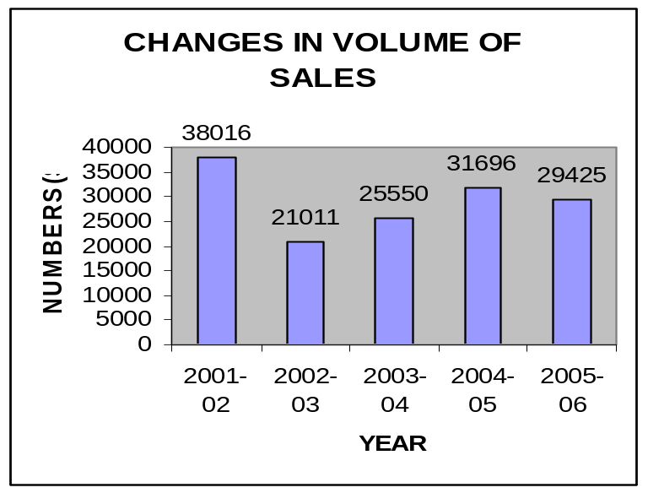

- The volume decreased by 17005 in 20002-03 as compared to that in 2001-02.
- There has been increased in the volume by 4539 in 2003-04 as compared to
that in 2002-03.
- There has been increased in the volume by 6146 in 2004-05 as compared to
that in 2003-04.
- The volume decreased by 2271 in 2005-06 as compared to that in 2004-05.

- 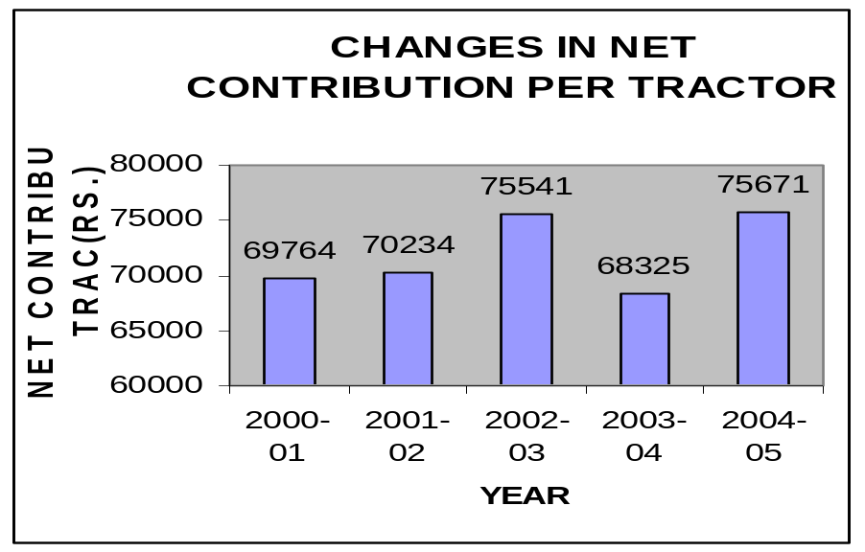The Net Contribution Per Tractor has increased considerably from the year 2001-02 to 2003-04 which can be seen in the graph below:

- The Net Contribution Per Tractor has increased considerably from 2001-02 to 2002-03,
that is an increase of Rs.5077 per tractor. This can be mainly attributed to changes in
Variable and material costs and in the price.
- The Net Contribution Per Tractor has decreased considerably from 2002-03 to 2003-04,
that is an decrease of Rs.7216 per tractor. This can be mainly attributed to changes in
Variable and material costs and in the prices.

- This increasing Net Contribution Per Tractor signifies that efficiencies have been achieved and had there been not such a drastic drop in volume. It could have lead to profits.

- The AMG could only achieve the following percentage of its budgeted volumes :

YEAR | % of BUD. VOLUME
2001-02 | 76
2002-03 | 50.03
2003-04 | 73
2004-05 | 76

These percentages can be explained by the graph.

These differences can be explained due to drop in actual sales as per the following reasons:
- Slump in the market
- Stiff competitions
- Emergence of foreign players

INTRODUCTION TO WORKING CAPITAL:

Working Capital Management is concerned with problems that arise in attempting to manage the current assets, the current liabilities and the interrelationship that exist between them. The term current assets refer to those assets which in ordinary course of business can be, or will be converted into cash within one year without undergoing a diminution in value and without disrupting the operations of the firm. The major current assets are cash, marketable securities, accounts receivable and inventory. Current liabilities are those liabilities which are intended, at their inception, to be paid in the ordinary course of business, within a year, out of current assets or earnings of the concern. The basic current liabilities are accounts payable, bills payable, bank overdraft and outstanding expenses. The goal of Working Capital Management is to manage the firm’s current assets and current liabilities in such a way that a satisfactory level of Working Capital is maintained. This is so because if the firm cannot maintain a satisfactory level of Working Capital, it is likely to become insolvent and may even be forced into bankruptcy. The current assets should be large enough to cover its current liabilities in order to ensure a reasonable margin of safety. Nevertheless the level of current assets should not be too high since in that case it will affect the overall profitability of the firm. The interaction between current assets and current liabilities is, therefore the main theme of Working Capital Management.

CONCEPT AND DEFINITIONS OF WORKING CAPITAL:

There are two concepts of working capital gross and net.
The term gross working capital, also referred to as working capital, means the total current assets.
The term net working capital is basically the difference between current assets and current liabilities. Efficient working capital management requires that the firm should operate with some amount of net working capital, the exact amount varying from firm to firm and depending, among other things, on the nature of the industry. The theoretical justification for the use of net working capital is based on the premise that greater the margin by which the current assets cover the short term obligations, the more is the ability to pay obligations when they become due for payment. The net working capital is necessary because cash outflows and inflows do not coincide. The cash outflows are relatively predictable, however cash inflows are difficult to predict. The more predictable the cash inflows are, the less net working capital is required.
Net working capital can alternatively be defined as that portion of current assets which is financed with long-term funds. Since current liabilities represent sources of short-term funds, as long as the current assets exceed the current liabilities, the excess must be financed with long-term funds.

The task of financial manager in managing working capital efficiently is to ensure sufficient liquidity in the operations of the enterprise. The liquidity of a business is measured by the firm’s ability to satisfy short-term obligations as they become due. The three basic measures of a firm’s overall liquidity are i) the current ratio, ii) the acid test ratio, and iii) the net working capital.

Thus the goal of working capital management is to manage the current assets and liabilities in such a way that an acceptable level of net working capital is maintained.

TRADE-OFF BETWEEN PROFITABILITY AND RISK:

The level of net working capital has a bearing on profitability as well as risk. Hence in evaluating firms net working capital position an important consideration is the trade-off between profitability and risk. Profitability refers to the net profits and risk refers to the probability of being insolvent so that the firm will not be able to meet its obligations when they become due for payment.

DETERMINING FINANCING MIX:
One of the most important decisions involved in the management of working capital is how current assets will be financed. There are broadly two sources from which funds can be raised for asset financing: i) short-term sources (current liabilities) ii) long-term sources, such as share capital, long term borrowings, internally generated resources like retained earnings and so on. Now what portion of current assets should be financed by current liabilities and how much by long-term resources?
There are basically three approaches to determine an appropriate financing mix: i) Hedging approach (or Matching approach) ii) Conservative approach iii) Trade-off between these two.

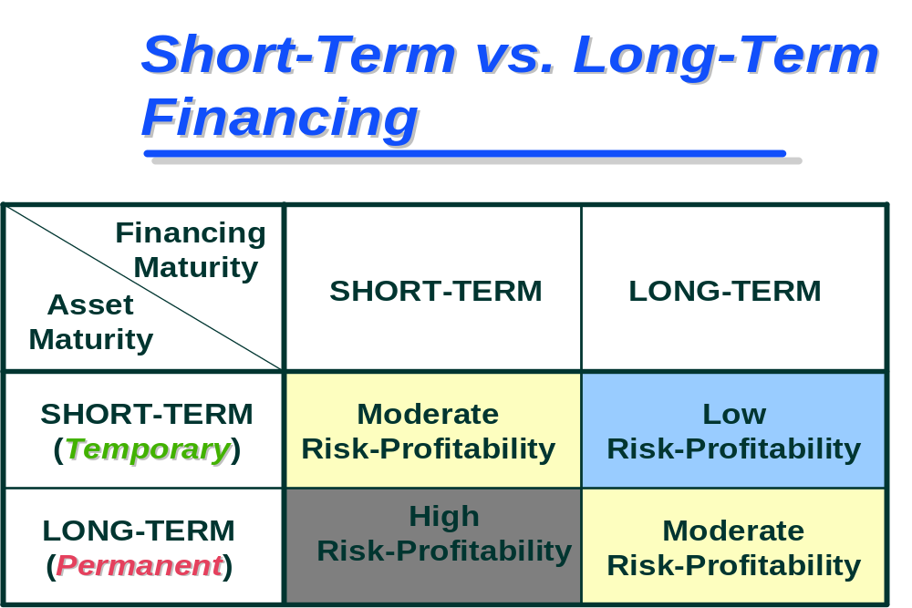

Hedging Approach:

With reference to appropriate financing mix, the term hedging can be defined as a process of matching maturing of debts with the maturities of financial needs. As per this approach the maturity of the sources of funds should match the nature of the assets to be financed. This approach suggest that long-term funds should be used to finance the fixed portion of current assets requirements whereas the temporary requirements, that is, the seasonal variations over and above the permanent financing needs should be appropriately financed with short-term funds. This approach is a high profit high risk approach to determine an appropriate financing mix.

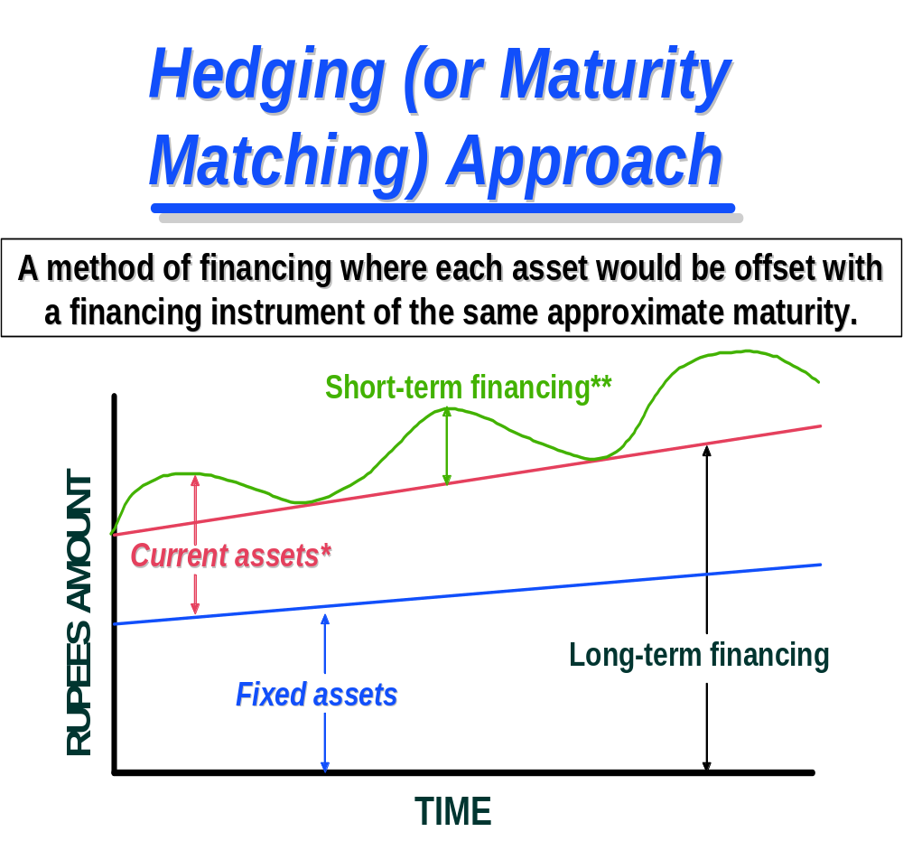

Conservative Approach:

This approach suggests that the estimated requirements of total funds should be met by long-term sources. The use of short-term sources should be restricted to only emergency situations or when there is an unexpected outflow of funds. This approach is high cost low risk approach to determine an appropriate financing mix.

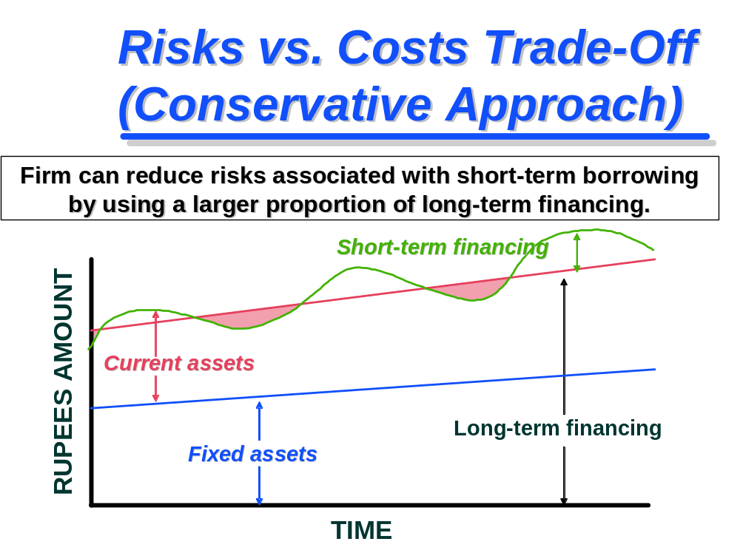

Trade-off between two:

Neither of the above two approaches would serve the purpose of efficient working capital management because of their extreme nature. A trade-off between these two would give an acceptable financing strategy.

Aggressive approach: This approach towards risk and profitability is such where the firm uses total short term borrowings for financing its working capital needs. This approach is very risky and always there is a chance of bankruptcy.

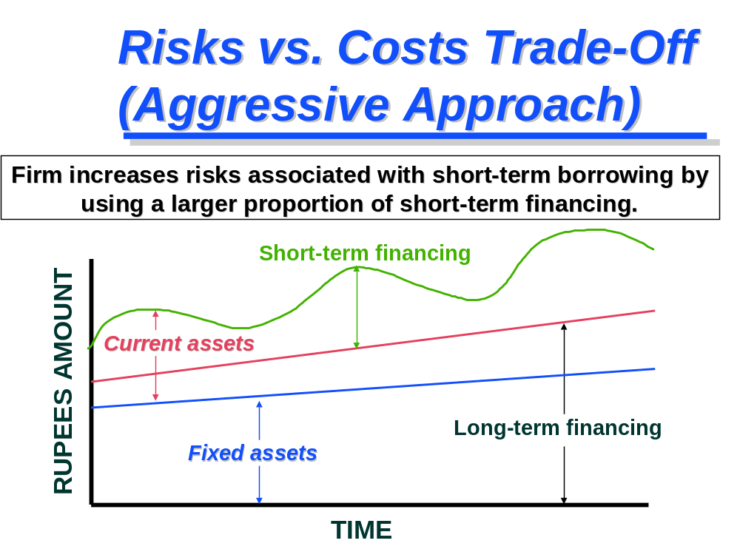

WORKING CAPITAL CYCLE:
The term operating cycle refers to the length of time necessary to complete the following cycle of events:
- Conversion of cash into inventory.
- Conversion of inventory into receivables.
- Conversion of receivables into cash.
Cash flows in a cycle into, around and out of a business. It is the business's life blood and every manager's primary task is to help keep it flowing and to use the cash flow to generate profits. If a business is operating profitably, then it should, in theory, generate cash surpluses. If it doesn't generate surpluses, the business will eventually run out of cash and expire.
The faster a business expands the more cash it will need for working capital and investment. The cheapest and best sources of cash exist as working capital right within business. Good management of working capital will generate cash will help improve profits and reduce risks. One must bear in mind that the cost of providing credit to customers and holding stocks can represent a substantial proportion of a firm's total profits.
There are two elements in the business cycle that absorb cash - Inventory (stocks and work-in-progress) and Receivables (debtors owing you money). The main sources of cash are Payables (your creditors) and Equity and Loans.
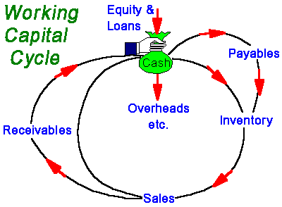
Each component of working capital (namely inventory, receivables and payables) has two dimensions........ Time ......... and Money. When it comes to managing working capital – Time is Money. If you can get money to move faster around the cycle (e.g. collect monies due from debtors more quickly) or reduce the amount of money tied up (e.g. reduce inventory levels relative to sales), the business will generate more cash or it will need to borrow less money to fund working capital. As a consequence, you could reduce the cost of bank interest or you'll have additional free money available to support additional sales growth or investment. Similarly, if you can negotiate improved terms with suppliers e.g. get longer credit or an increased credit limit; you effectively create free finance to help fund future sales.

If you....... | Then......
- Collect receivables (debtors) faster | You release cash from the cycle
- Collect receivables (debtors) slower | Your receivables soak up cash
- Get better credit (in terms of duration or amount) from suppliers | You increase your cash resources
- Shift inventory (stocks) faster | You free up cash
Move inventory (stocks) slower | You consume more cash

It can be tempting to pay cash, if available, for fixed assets e.g. computers, plant, vehicles etc. If you do pay cash, remember that this is no longer available for working capital. Therefore, if cash is tight, consider other ways of financing capital investment - loans, equity, leasing etc. Similarly, if you pay dividends or increase drawings, these are cash outflows and, like water flowing downs a plug hole, they remove liquidity from the business.
Computation of Operating Cycle:
Operating Cycle = R+W+F+D-C
R= Raw material storage period
W= Work-in-progress period
F= Finished goods storage period
D= Debtors collection period
C=Creditors deferral Period
The various components of operating cycle may be calculated as shown below:

- (1) Raw Material storage period = Average stock of raw material
Average cost of raw material consumption per day

- (2) Work-in-progress holding period = Average work-in-progress inventory
Average cost of production per day
- (3) Finished goods storage period = Average stock of finished goods
Average cost of goods sold per day
- (4) Debtors collection period = Average book debts
Average credit sales per day
- (5) Credit collection period = = Average trade creditors
Average credit purchases per day

PERMANENT AND TEMPORARY WORKING CAPITAL:
Permanent working capital is the minimum level of working capital required on a continuous and uninterrupted basis. Any amount over and above the permanent level of working capital is temporary, fluctuating or variable working capital. This portion of the required working capital is needed to meet fluctuations in demand consequent upon changes in production and sales as a result of seasonal changes.
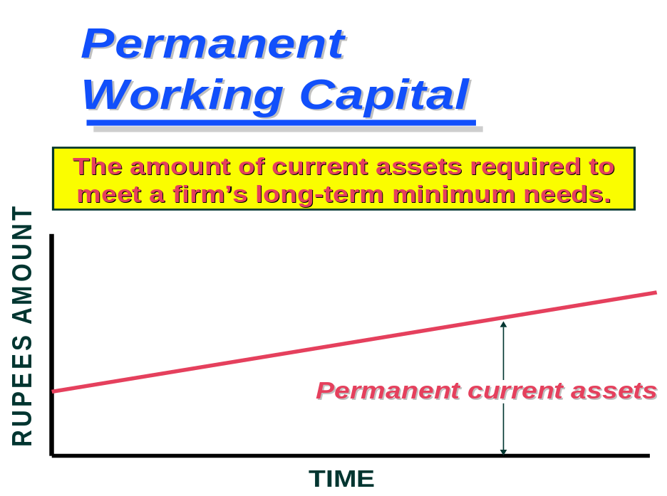

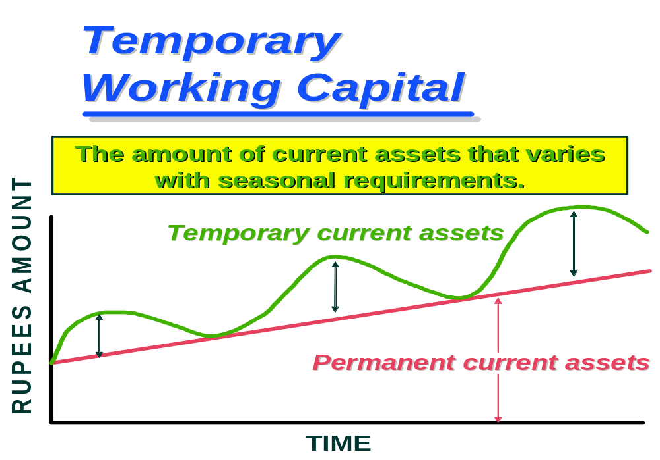

DETERMINANTS OF WORKING CAPITAL:
General nature of business: The working capital requirements of an enterprise depend upon the nature of the business. The proportion of current assets to total assets measures the relative requirements of working capital of various industries. Some peculiar features applicable in some industries which have a bearing upon their working capital needs could be i) the cash nature of business i.e. cash sale ii) sale of services rather than commodities.
Production cycle: Production cycle i.e. the time involved in the manufacture of goods has also a bearing upon the quantum of working capital. It covers the time span between the procurement of raw materials and the completion of manufacturing process leading to the production of finished goods. Funds have to be necessarily tied up during the process of manufacture, necessitating enhanced working capital. That is there is some time gap before raw materials become finished goods. To sustain such activities the need of working capital is obvious. The longer the time span or production cycle, the larger will be the tied up funds and therefore, larger the working capital needed and vice-versa. In some cases a part of financial burden relating to manufacturing cycle time is passed on to others like in case of companies manufacturing heavy machinery and equipment minimize the investment in inventory or working capital by requiring advance payments from customers as work proceeds against orders.

Business cycle: The working capital requirements are also determined by the nature of the business cycle. Business fluctuations lead to cyclical and seasonal changes which, in turn, cause a shift in the working capital position, particularly for temporary working capital requirements. These variations may take place in two directions i) upward phase when boom conditions prevail ii) downsizing phase when economic activity is marked by a decline. During the upswing of business activity, the need of working capital is likely to grow to cover the lag between increased sales and receipt of cash as well as to finance purchase of additional materials to cater to the expansion of the level of activity. The downsizing phase of the business cycle has exactly an opposite effect on the level of working capital requirements. The decline in the economy is associated with a fall in the volume of sales which, in turn, leads to a fall in the level of inventories and book debts. The need for working capital in recessionary conditions is bound to decline. In short, business fluctuations influence the size of working capital mainly through the effect on inventories.
Production policy: The quantum of working capital is also determined by production policy. In case of certain lines of business, the demand for products is seasonal, that is, they are purchased during certain months of the year.
Credit policy: The credit policy relating to sales and purchases also affects the working capital in two ways: i) through credit terms granted by the firm to its customers/ buyers of goods ii) credit terms available to the firm from its creditors. The credit sales result in higher book debts. Higher book debts mean more working capital. On the other hand, if liberal credit terms are available from the suppliers of goods (trade creditors), the need of working capital is less. Hence, adoption of rationalized credit policies would be a significant factor in determining the working capital needs of an enterprise. However such discretion may not be available to a company which operates in a highly competitive market. The degree of competition is, therefore, an important factor influencing working capital requirements.
Growth and expansion: As a company grows, it is obvious to expect a larger amount of working capital. However, it is difficult to determine precisely the relationship between the growth and volume of the business of a company and the increase in its working capital. Advance planning of working capital is, therefore, a continuing necessity for a growing concern.
Vagaries and availability of raw materials: In case of chances of interruption of availability of certain raw materials on a continuous basis would sometimes affect the requirement of working capital. There may be some materials which cannot be procured easily either because of their sources are few or they are irregular. Hence to sustain smooth production, therefore, the firm might be compelled to purchase and stock them far in excess of genuine production needs. This will result in excessive inventories of such materials. Also some raw materials may be available only during certain seasons. They would have to be necessarily obtained, when available, to provide for a period when supplies are lean.
Profit Level: The net profit is a source of working capital to the extent it has been earned in cash. Higher profit margin would improve the prospects of generating more internal funds, thereby contributing to the working capital pool. Cash profit refers to the profit earned after adjusting non-cash items such as depreciation, outstanding expenses, and losses written off. The availability of internal funds for working capital requirements is determined not merely by the profit margin, but also by the manner of appropriating profits. The availability of such funds would depend upon the profit appropriations for taxation, dividend, and reserves. For e.g. the taxes to be paid is determined by the prevailing tax regulations. The management has no discretion in this respect. Many times taxes have to be paid in advance on the basis of the profit and management has no discretion in regard to the payment of taxes, in some cases non-payment may attract penal action.

Tax planning can, therefore, be said to be an integral part of working capital planning. Similarly, dividend policy also has a bearing on working capital requirements. The payment of dividend consumes cash resources and, thereby, affects working capital to that extent. Conversely, if the firm does not pay dividends but retains the profit, working capital increases. In theory, a firm should retain profits to preserve cash resources and, at the same time, it must pay dividends to satisfy the expectations of the investor. The choice whether to retain or disburse profits must be made after taking into consideration all the relevant factors. Dividend policy, is thus, a significant element in determining the level of working capital in an organization. Depreciation policy also exerts an influence on the quantum of working capital. Depreciation charges do not involve any cash outflow. The effect of depreciation policy on working capital is, therefore, indirect. Depreciation affects the tax liability and retention of profits. Enhanced rates of depreciation lower the profits and, therefore, the tax liability and, thus, more cash profits. Higher depreciation also means lower disposable profits and, therefore, a smaller dividend payment. Thus, cash is preserved.
Price level changes: Changes in price level also affects the requirement of working capital. Rise in prices necessitate the use of more funds for maintaining an existing level of activity. For the same level of current assts, higher cash outlays are required. The effect is that higher working capital is required. However, if the firm is able to increase the prices proportionately, there is no serious problem as regards working capital.
Operating Efficiency: The operating efficiency of the management is also an important determinant level of working capital. The management can contribute to a sound working position through operating efficiency. Although the management cannot control the rise in prices, it can ensure the efficient utilization of resources by eliminating waste, improving co-ordination, and a fuller utilization of existing resources, and so on.

To conclude the level of working capital is determined by a wide variety of factors which are partly internal to the firm and partly external to it. Efficient working capital management

requires efficient planning and a constant review of the needs for an appropriate working capital strategy
COMPUTATION OF WORKING CAPITAL:
The two components of working capital are current assets and current liabilities. In order to calculate the working capital needs what is required is the holding period of various types of inventories, the credit collection period and the credit deferral period. The working capital also depends on the budgeted level of activity in terms of production/sales. The calculation is based upon the assumption that the production/sales is carried out evenly throughout the year and all costs accrue similarly. The steps involved in estimating the different items of current assets and current liabilities are as follows:
ESTIMATION OF CURRENT ASSETS :
Raw Materials Inventory: The funds to be invested in raw materials inventory may be estimated on the basis of production budget, the estimated cost per unit and an average holding period raw material inventory by using the following formula:

Budgeted production x Cost of raw materials per unit x Average raw material holding period in days/months
12months/365 days

Work-in progress Inventory : The funds to be invested in work-in-progress can be estimated by the following formula:
Budgeted production x Cost of W-I-P per unit x Average W.I.P holding period in days/months
12months/365 days

Finished goods: The funds to be invested in finished goods can be estimated by the following formula:
Budgeted production x Cost of Production per unit x Average finished goods holding period in days/months
12months/365 days

Debtors : The funds to be invested in debtors can be estimated by the following formula:
Estimated credit sales x Cost of Sales per unit x Average debtors collection period in days/months
12months/365 days
Cash Balance: Minimum desired cash and bank balances to be maintained by the firm has to be added in current assets for computation of computation of working capital Estimation of Current Liabilities : The amount of working capital is lowered to the extent of current liabilities arising in the normal course of business.
Trade Creditors: This can be estimated by the following formula:
Estimated credit purchases x Raw Materials Requirement per unit x Credit period granted by suppliers in days/months
12months/365 days
Direct Wages: This can be estimated by the following formula:
Budgeted production x Direct Labour per unit x Average time lag in payment in days/months
12months/365 days

Overheads: This can be estimated by the following formula:
Estimated yearly production x Overhead costs per unit x Average time lag in payment in days/months
12months/360 days
Note: The amount of overheads may be separately calculated for different types
of overheads. In case of selling overheads the relevant item would be sales volume instead of production volume.

Working Capital Financing

Trade Credit:

Trade credit refers to the credit extended by the supplier of goods and services in the normal course of transaction/business/sale of the firm. i.e. cash is not paid immediately for purchases but after an agreed period of time. Thus, deferral of payment represents a source of finance for credit purchases.
There is however, no formal formal/specific negotiation for trade credit. It is an informal arrangement between the buyer and seller without any legal instruments or acknowledgements of debts. Such credit appears in the record of buyer of goods as sundry creditors/accounts payable.

Advantages:

Trade credit, as a source of short working capital finance has certain advantages. These are as follows.

  - It is easily, almost automatically available.
  - It is flexible and spontaneous source of finance.
  - It is free from restrictions associated formal negotiated source of finance.
  - Trade credit does not involve any explicit charges.

Bank Credit:

Bank credit is the primary institutional source of working capital finance in India. In fact, it represents the most important source of financing current assets.

Forms of credit:
Working capital finance is provided by banks in five ways: (i) cash credits/overdrafts. (ii) Loans. (iii) purchase/discount bills, (iv) letter of credit, and (v) working capital term loans.

Cash Credit/overdrafts: Under cash credit/overdraft form/arrangement of bank finance, the bank specifies a predetermined borrowing/credit limit. The borrower can borrow/draw up to the stipulated credit/overdraft limit. Within the specified limit/line of credit, any number of drawals/drawings is possible to the extent of his requirements periodically. Similarly, repayments can be made whenever desired during the period. The interest rate determined on the basis of running balance actually utilized by the borrower and not the sanctioned limit. However, a minimum (commitment) charge may be payable on the unutilized balance. This form of financing is convenient and flexible for the borrowers.

Loans: Under this arrangement, the entire amount of borrowing is credited to the current account of the borrower of or realize in cash. The borrower has to pay the interest on the total amount. The loans are repayable on demand or in periodic installments. They can also be renewed from time to time.

Bills purchased/Discounted: These bills work as a source of working capital finance and arise out of trade sale, purchase transaction on credit. The seller of goods draws the bill on the purchaser of goods, payable on demand or after a usance period not exceeding 90 days. On acceptance of bill by the purchaser, the seller offers it to the bank for discount/purchase. On discounting the bill the bank realizes the funds to the seller. The bill is presented by the bank to the purchaser on due date for payment.

Letter of Credit: A Letter of Credit (more correctly called a Documentary Credit) is an arrangement whereby a bank, operating on the instructions of an importer, authorizes another bank to pay a fixed sum to an exporter on production of specified documents. The rules governing the use of Letters of Credit are contained in Uniform Customs and Practice for Documentary Credits (ICC No. 400) available from most Banks.
Working Capital Term Loans: Under this arrangement, bank advances loans for 3 to 7 years repayable in yearly or half-yearly payments.
Mode of Security: Banks provide credit on the basis of the following modes of security:
  - Hypothecation: Under this mode the banks provide credit to borrowers against the collateral security of movable property, usually inventory of goods. The goods hypothecated however, continue to be in the possession of the owner of these goods i.e. the borrower. Although the bank does no have the physical possession of the goods, it has the legal right to sell the goods to realize the outstanding loan.
  - Pledge: Pledge, as a mode of security, is different from hypothecation because in case of pledge the goods are transferred to the physical possession of the lender. The borrower, who offers the security is, called a ‘pawnor’ (pledgor), while the bank is called the ‘pawnee’ (pledgee). However the bank must take reasonable care of the goods pledged with it i.e. care which a prudent person would take to protect his property.
  - Lien: it refers to a right of a party to retain goods belonging to another party until a debt due to him is paid. It can be of two types: i) particular lien, and ii) general lien. Particular lien is a right to retain goods until a claim pertaining to these goods is fully paid. Whereas general lien can be applied till all dues of the claimant are paid.
  - Mortgage: It is the transfer of a legal/equitable interest in specific immovable property for securing the payment of debt. The person who parts with the interest in the property is called ‘mortgagor’ and the bank in whose favour the transfer takes place is the ‘mortgagee’. It is thus the conveyance of interest in the mortgaged property.

COMMERCIAL PAPERS:
Commercial paper is a short-term unsecured negotiable instrument, consisting of usance promissory notes with a fixed maturity An unsecured obligation issued by a corporation or bank to finance its short-term credit needs, such as accounts receivable and inventory. Maturities typically range from 2 to 270 days. Commercial paper is available in a wide range of denominations, can be either discounted or interest-bearing, and usually have a limited or nonexistent secondary market. Commercial paper is usually issued by companies with high credit ratings, meaning that the investment is almost always relatively low risk.

Framework of Indian CP market: Commercial papers are regulated by the RBI. The main elements of the present framework are as follows:

- CPs can be issued for a period ranging between 15 days and 1 year. Renewal of CPs is treated as fresh issue.
- The minimum size of an issue is 25 lakhs and minimum unit of subscription is 5 lakhs.
- The maximum amount that a company can raise by way of CPs is 100% of the working capital limit.
- A company can issue CPs only if it has a minimum tangible net worth of Rs. 4 crores, a fund based working limit of Rs. 4 crores or more, at least a rating of P2 ( CRISIL) , A2(ICRA),etc.
- The holder of Cps would present them for payment to the issuer on maturity

FACTORING:
Factoring provides resources to finance receivables as well as facilitates the collection of receivables. Factoring can be broadly defined as an agreement in which receivables arising out of sale of goods/services are sold by a firm(client) to the factor(a financial intermediary) as a result of which the title of goods/services represented by the said receivables passes on to the factor. Hence, factor becomes responsible for credit control, sales accounting and debt collection from the buyers. In case of factoring without recourse facility, if any debtor fails to pay the dues as a result of financial inability or insolvency the factor has to absorb the loss.

FUNCTIONS OF THE FACTOR:

- Financing facility.
- Maintenance and administration of sales ledger.
- Collection of account receivables.
- Provision of advisory services.
- Assumption of credit risk and control.

ADVANTAGES OF FACTORING:

- Of Balance sheet Financing: Since the client’s debts are purchased by the factor, the finance provided by him is off the balance sheet and appears in the balance sheet only as a contingent liability in case of recourse factoring.
- Reduction of current Liabilities:
- Improvement in current ratio: As the factoring transaction off the balance sheet, it removes from the asset side the receivables factored to the extent of the pre-payment made and on the liabilities’ side the current liabilities are also reduced.

- Higher credit standing: With cash flow accelerated by factoring, the client is able to meet its liabilities promptly as and when they arise. The factor’s acceptance in the client’s receivables itself speaks highly of the quality of the receivables.

- Improved efficiency: In order to accelerate cash flow it is essential to ensure the flow of critical information for decision making and follow-up and eliminate delays and wastage of man-hours.

- More time for planning and production: The factor undertakes the responsibility for credit control, sales ledger administration and debt collection problems. Thus, the client can concentrate on functional areas of the business planning, purchase, production, marketing and finance.

- Reduction of cost and expenses: Since the client need not have a special administrative setup to look after the credit control he can have the benefit of reduced overheads by way of savings on man-power, time and effort.

CASH MANAGEMENT

INTRODUCTION:

Cash management is one of the key areas of working capital management. Apart from the fact that it is the most current liquid assets, cash is the most common denominator to which all the current assets can be reduced because the other major liquid assets, that is, receivables and inventory get eventually converted into cash. This underlines the significance of cash management.

MOTIVES FOR HOLDING CASH:

The term cash with reference to cash management is used in two senses. In a narrow sense, it is used to cover currency and generally accepted equivalents of cash, such as cheques, drafts, demand deposits in banks. The broad view of cash also includes near-cash such as marketable securities and time deposits in banks. The main characteristics of these are that they can be readily sold and converted into cash. Here, the term cash management is employed in the broader sense. Irrespective of the form in which it is held, a distinguishing feature of cash, as an asset, is that it has no earning power. If cash does not earn any return why it is held? There are four primary motives for maintaining cash balances:

1) Transaction Motive:
This is a motive of holding cash/near-cash to meet routine cash requirements to finance the transactions which a firm carries on in the ordinary course of the business. A firm enters into a variety of transactions to accomplish its objectives which have to be paid for in the form of cash. For e.g. cash payments have to be made for purchases, wages, operating expenses, financial charges, and so on. Similarly, there is a regular inflow of cash to the from sales operations, returns on investments and so on. These receipts and payments constitute a continuous two way of cash, but they do not coincide or synchronize. Hence, in case, the disbursements are in excess of current receipts the need of cash balance is obvious.

2) Precautionary Motive:
In addition to the non-synchronization of anticipated cash inflows and outflows in the ordinary course of business, a firm may have to pay the cash for the purposes which cannot be predicted or anticipated. The unexpected cash needs at the short notice may be the result of floods, strikes, and bills may be presented for settlement earlier than expected, unexpected slowdown in collection of accounts receivables, cancellation of some order of goods from customers, sharp increase in cost of raw materials, etc. hence precautionary balances to meet unpredictable obligations are required to provide a cushion to meet unexpected contingencies. Such cash balances are usually held in the form of marketable securities so that they earn a return.

3) Speculative Motive:
It refers to the desire of the firm to take advantage of opportunities which present themselves at unexpected moments and which are typically outside the normal course of business. While the precautionary motive is defensive in nature, that firms must make provisions to handle unexpected contingencies, the speculative motive represents a positive and aggressive approach. Firms’ aim to exploit profitable opportunities and keep cash in reserve to do so. The speculative motive helps to take advantage of: an opportunity to purchase raw material at a reduced price on payment of immediate cash, a chance to speculate on interest rate movements by buying securities when interest rates are expected to decline.

4) Compensative Motive:
Yet another motive to hold cash balances is to compensate banks for providing certain services and loans. Banks provide a variety of services such as clearance of cheques, supply of credit information and so on. While for some of this services banks charge a commission or fee for other they seek indirect compensation. Usually, the clients are required to maintain a minimum balance of cash at the bank and the bank could return on such balances. Compensating balances are also required by some loan agreements between a bank and its customers.

FACTORS DETERMINING CASH NEEDS:

Synchronization of cash flows: The need of maintaining cash balances arises from the non-synchronization of the inflows and outflows of cash. Hence the extent of non-synchronization of cash receipts and disbursements determines the cash needs. For this a proper forecast over period of time has to be made by making cash budgets.

Short costs: another factor to be considered in determining cash needs is the costs associated with the shortfall in the cash needs. Some of the costs included in short costs are as under:
- Transaction costs associated with raising cash to cover the shortage.
- Borrowing costs associated with the borrowing to cover the shortage like interest, commitment charges, etc.
- Loss of cash discount which cannot be availed because of the shortage of cash.
- Cost associated with the deterioration of the credit rating which is reflected in higher bang charges, stoppage of supplies, refusal to sell, loss of image.
- Penalty rates by the bank to meet short fall in compensating balances.

Excess cash balance costs: The cost of having excessively large balances is known as excess cash balance cost. Basically it is the loss of interest on idle funds which could have been earned if invested somewhere.

Procurement and management: These are the costs associated with establishing and operating cash management staff and activities. These are mainly fixed in nature like salaries, etc.

Uncertainty: The impact of uncertainty on cash management strategy is also relevant as cash flows cannot be predicted with precise accuracy. The motive is to provide a precautionary cushion to cope up with irregularities in cash flows, unexpected delays in collections and disbursements.

CASH BUDGET:

A firm is well advised to hold adequate cash balances but should avoid excessive balances. The firm has; therefore, to assess its cash needs properly. The cash budget is probably the most important tool in cash management. It is a device to help a firm to plan and control the use of cash. It is a statement showing inflows and outflows of cash over a period of time.

Purposes of cash budget:
- To co-ordinate the timings of cash needs.
- It pin-points the period when there is likely to be excess cash.
- It enables a firm which has sufficient cash to take advantage of cash discounts on its accounts payable, to pay obligations when due, to take dividend decisions.
- It helps to arrange needed funds on the most favourable terms and prevents the accumulation of excess funds.

ELEMENTS OF CASH BUDGET:

The principal aim of cash budget, as a tool to predict cash flows over a given period of time, is to ascertain whether at any point of time there is likely to be an excess or shortage of cash. The elements of cash budget are as follows:

- The first element of cash budget is the selection of the period of time to be covered by the budget. It is referred to as the planning horizon. The coverage of the cash budget will differ from firm to firm depending upon its nature and the degree of accuracy with which the estimates can be made. However, the period selected should neither be too short or too long. If it is too short, many important events which lie just beyond the period cannot be accounted for and the work associated with the preparation of the budget becomes excessive. If it is too long, the chances of inaccuracy will be high. The planning horizon of cash budget depends upon the circumstances and requirements of a particular case. If the flows are expected to be stable and dependable, such from may prepare a cash budget covering a long period. However, in case of a firm whose flows are uncertain a short period budget may be appropriate.
- The second element of cash budget is the selection of the factors that have a bearing on the cash flows. The items included in cash budget are only cash items; non-cash items such as depreciation and amortization are excluded.

TABLE 1
Cash Budget for the ___Months
Ended ______________

Worksheet Oct. Nov. Dec. Jan. Feb. June July Aug.
Sales
Collections:
First month (30%)
Second month (50%)
Third month (20%)
Total
Purchases
Payments (one-month lag)
Cash receipts:
Collections
Cash disbursements:
Purchases
Wages and salaries
Rent
Other expenses
Taxes
Purchase of equipment
Loan repayment
Total disbursements:
Net monthly charge
Plus: Beginning cash balance
Less: Interest on short-term borrowing
Equals: Ending cash balance—no borrowing
Financing needed
Ending cash balance
Cumulative borrowing
ª The amount of financing that is required to raise the firm’s ending cash balance up to _______ $10,000 desired cash balance.
^{b} Negative financing needed simply means the firm has excess cash that can be used to retire a part of its short-term borrowing from prior months

CASH MANAGEMENT TECHNIQUES:

Speedy cash collections: The customers should be encouraged to pay as quickly as possible. One way to ensure prompt payment to by the customers is prompt billing. What the customer has to pay and when has to be specified clearly in advance. Another technique for encouraging prompt payment by customers is to offer cash discounts. The availability of discount implies considerable savings to the customers. To avail the facility, customers would be eager to make payment. Secondly, the payment from customers should be converted into cash without any delay. That as once the customers makes the payment by writing a cheques in favour of the firm, the collection can be expedited by prompt encashment of the cheques. There is a lag between the time a cheques is prepared and mailed by the customer and the time the funds are included in the cash reservoir of the firm. The collection of accounts receivable can be considerably accelerated, by reducing transit, processing and collection time. An important cash management technique is reduction in deposit float. This could be possible if the firm adopts a policy of decentralized collections. The princi9pal methods of establishing a decentralized collection network are:

- Concentration banking: In this system of decentralized collection of accounts receivable, large firms having large branches, select strategically some of the branches as collection centre for receiving payments from customers. Instead of all the payments being collected at head office, the cheques are collected at the local collection centre and the customers are required to send their payments to the collection centre covering the area in which they live. The funds collected are then transferred to concentration or central bank.

- Lock Box: This is basically a collection procedures in which payers send their payments/ cheques to a nearby post box that is emptied by the firm’s bank several times and the bank deposits the cheques in the firm’s account. Thus, the lock box system is like concentration banking in that the collection is decentralized. This arrangement is an improvement over concentration banking as some extra saving in the mailing time is provided by this system as the cheques received in the post box are not delivered by the firm itself to the bank; rather the bank itself collects them up.

Slowing Disbursements: Apart from speedy collections of accounts receivable, the operating cash requirements can be reduced by slow disbursements of accounts payables. The various techniques to delay payment of accounts payable are:

- Avoidance of early payments: It is not advisable for a firm to make payments to the parties early, that is, before its due date. However payments should not be delayed after due date otherwise the credit standing may be adversely affected and the firm will not be able to secure trade credit in future.

- Centralized Disbursements: The payments should be made by the head office from a centralized disbursement account. Such an arrangement would enable a form to delay payments and in turn will be able to conserve cash since it will increase the transit time. The remittance from the head office to its customers at distant places would involve more mailing time than a decentralized payment by a local branch. Not only this having a centralized disbursement arrangement, is a relatively smaller cash balance needed since there is no need to maintain cash balance at branches.

- Float: A very important technique of slow disbursement is float. The term float refers to the amount of money tied up in cheques that have been written, but have yet to be collected and en-cashed.

- Paying from a distant bank: The firm may issue a cheque on banks away from its creditors. This would involve longer transit time for the creditor’s bank to get payment and, thus, enable a firm to use its funds longer.

- Cheque-encashment analysis: Another way to make use of float is to analyze, on the basis of past experience, the time lag in the issue of cheques and their encasements.

- Accruals: Finally, a potential tool for stretching accounts payable is accruals which are defined as current liabilities that represent a service or goods received by a firm but not yet paid for. For instance, payroll, i.e. remuneration to the employees who render service in advance and receive payment later. In a way, they extend credit to the firm for a period at the end of which they are paid, say, a week or a month.

Receivables Management

INTRODUCTION:

The receivables represent an important component of the current assets of any firm. The term receivables are defined as ‘debt owe to the firm by the customers arising from sale of goods and services in the ordinary course of business’. When a firm makes an ordinary sale of goods or services and does not receive payment, the firm grants trade credit and creates accounts receivable. It is also referred as trade credit management. Management should way the benefits as well as the costs to determine the goal of receivables management.

OBJECTIVES:

The credit sales are generally made on open account in the sense that there are no formal acknowledgements of debt obligations through a financial instrument. As a marketing tool, they are intended to promote sales and thereby profits. However, extension of credit involves risks and costs. The objective of receivables management is ‘to promote sales and profit’ until that point is reached where the return on investments in funding receivables is less than the cost of funds raised to finance the additional credit. The specific costs and benefits which are relevant to the determination of objectives of receivable management are stated below:

- Costs: The major categories of costs associated with accounts receivable are: i) collection costs ii) capital costs iii) delinquency cost iv) default costs.

  - Collection costs: These are administrative costs incurred in collecting the receivables from the customers to whom credit sales have been made.

  - Capital costs: The increased level of account receivable is an investment in assets. They have to be financed involving a cost. The cost on the use of additional capital to support credit sales could be profitably employed.

  - Delinquency costs: It is the costs arising out of failure of customers to pay on due date. The important components of this cost are: i) blocking of the funds for an extended period ii) costs associated with steps that have to be initiated to collect the overdues.

  - Default costs: These are the overdues that cannot be recovered. Such debts are treated as bas debts and have to be written-off as they cannot be realized.

- Benefits: The benefits are the increased sales and anticipated profits because of a more liberal policy. When firms extend trade credit, i.e. invest in receivables, they intend to increase the sales. The impact of the liberal trade credit policy is likely to take two forms. First, it is oriented to sales expansion. In other words, a firm may grant trade credit either to increase sales to existing customers or attract new customers. This motive for investment in receivables is growth oriented. Secondly, the firm may extend credit to protect its current sales against emerging competition. Here, the motive is sales retention. As a result of increased sales the profit of the firm will increase.

Credit Policies: It is the determination of credit standards and credit analysis. The credit policy of a firm provides the framework to determine: a) whether or not to extend credit to a customer and b) how much credit to extend. The credit policy decision of a firm has two dimensions: i) credit standards ii) credit analysis.

- Credit standards: These are the basic criteria/minimum requirement for extending credit to a customer. The factors for establishing standards are credit rating, credit references, average payment period, and financial ratios. The trade-off with reference to credit standards cover i) the collection costs ii) average collection period/cost of investment in accounts receivable iii) level of bad debt losses iv) level of sales. The implications of the four factors are explained below.

  - Collection costs: The implications are: i) more credit ii) a large credit department to service accounts receivable iii) increase in collection cost.

  - Investment in receivables: The investment in account receivable involves a capital cost as funds have to be arranged by the firm to finance them till customers make payments. Higher the average accounts receivable, the higher will be the capital or carrying costs.

  - Bad debt losses: These can be expected to increase with relaxation in credit standards and decrease if credit standards become more restrictive.

  - Level of Sales: As standards are relaxed, sales are expected to increase; conversely, a tightening is expected to cause a decline in sales.

    - Credit analysis: It involves obtaining credit information and analysis of credit information. It is on the basis of credit analysis that the decisions to grant credit to a customer as well as the quantum of credit would be taken.
      - Obtaining credit information: The first step is to obtain credit information on which the base is the evaluation of the customer. The sources of information are: i) internal ii) external.

Internal: The firm requires the customers to fill various forms and documents giving details about financial operations. Another internal source is derived from the records of the firm contemplating an extension of credit.

External: The availability of information from external; sources to assess the credit worthiness of the customers depends upon development of institutional facilities and industrial practices. The external sources are financial statements, bank references, trade references and credit bureau reports.
- Analysis of credit information: Once the credit information has been collected from different sources, it should be analysed to determine the credit worthiness of the applicant. It covers two aspects: i) quantitative and ii) qualitative.

Quantitative: It is based on the factual information available from financial statements, the past records of the firm and so on.

Qualitative: It would cover aspects related to quality of management. Here, the references from other suppliers, bank references and specialists bureau reports would form the basis for conclusions to be drawn.

Credit terms: It specify the repayment terms required of receivables. Credit terms have three components: i) credit period, in terms of duration of time for which trade credit is extended to customers in case of credit sales ii) cash discount is the incentive to the customers to make early payment of sum due iii) cash discount period is the duration of the period during which discount can be availed off. The credit terms like credit standards, affect the profitability as well as the cost of the firm. A firm should determine the credit terms on the basis of cost benefit trade-off. It should be noted that the focus in analyzing credit terms is from the view point of suppliers of trade credit and not for the recipients for whom it plays a source of financing.

Inventory Management

Introduction:

The term inventory refers to the stock of the products a firm is offering for sale and the components that make up the product. That is, inventory is composed of assets that will be sold in future in the normal course of business operations. These assets are i) Raw materials, ii) Work-in-progress and iii) Finished goods. The views concerning the appropriate level of inventory would differ among the different functional areas.

Objectives:

Efficient management of inventory should ultimately result in the maximization of owners’ wealth. The inventory should be turned over as quickly as possible, avoiding stock-outs that might result in closing down the production line or lead to a loss of sales. It implies that while the management should try to pursue the financial objectives of turning inventory as quickly as possible, it should at the same time ensure sufficient inventories to satisfy production and sale demand, that is, these two conflicting requirements have to be reconciled. Alternatively, we can say that the objective of inventory management is to minimize investment is inventory and also to meet a demand for the product by efficiently organizing the production and sales operation. That is to say, an optimum level of inventory should be determined on the basis of the trade-off between costs and benefits associated with the level of inventory.

COST OF HOLDING INVENTORY:

The objective of inventory management is to minimize costs. The costs associated with the inventory fall into two basic categories: i) ordering costs, and ii) carrying costs. These costs are an important element of the optimal level of inventory decisions and are described as under:

    - Ordering costs; these are the costs associated with the acquisition or ordering of inventory. It is the fixed cost of placing and receiving an inventory order. Included in the ordering costs are costs involved in one i)preparing a purchase order or requisition form and ii) receiving, inspecting and recording of the goods received to ensure both quality and quantity. These are generally fixed irrespective of the amount of order. Hence, such costs can be minimized by placing fewer orders for a larger amount. However, acquisition of large quantity would increase the costs associated with the maintenance of the inventory, that is, carrying costs.

    - Carrying costs: these costs are the variable costs per unit of holding an item in inventory for a specified time period. These costs can be divided into two categories. i) those that arise due to storing of inventory: the main components of this category of costs are a) the storage costs, insurance, maintenance of the building b) insurance of inventories against fire and theft, c) deterioration in inventory because of pilferage, fire, technical obsolescence, d) serving costs such as labour for handling, ii) opportunity costs: this consists of expenses in raising funds. If funds were not blocked up in inventory, they would have earned a return. This is the opportunity cost of funds.

The sum of ordering and carrying costs represents the total cost of inventory.
Benefits of holding inventory:
The secondary element in the optimum inventory decision deals with the benefits associated with holding inventory. The major benefits of holding inventory is that they enable firms in the short run to produce at a rate greater than purchase of raw materials and vice-versa, or sell at rate greater than production and vice-versa.

Inventory Management Techniques:
Many sophisticated mathematical techniques are available to handle inventory management problems.

- Classification System: A B C System; The ABC system is a widely used classification technique to identify various items of inventory for the purposes of inventory control. This technique is based on the assumption that firm should not exercise the same degree of control on all items of inventory. It should rather keep a more rigorous control on items that are most costly and or slowest turning, while items that are less expensive should be given a less control. Hence, ABC system is an inventory management technique that divides inventory into three categories of descending importance based on rupee investment in each. The items included in group A involve the largest investment. Therefore, inventory control should be most rigorous and intensive and the most sophisticated inventory control, techniques should be applied to these items. The C group items consist of items of inventory which involve relatively small investments, although the number of items is fairly large. These items deserve minimum attention. The group B stands mid-way. It deserves less attention than A but more than C. It can be controlled by employing less sophisticated techniques.
The task of inventory management is to classify all the inventory items into one of these groups/categories.

- Order quantity problem: EOQ model; Economic order quantity model is the inventory management technique for determining items optimum order quantity which is the one that minimizes the total of its ordering and carrying costs. It balances fixed ordering cost against variable ordering costs. It is also known as economic lot size. Mathematically it can be calculated by the following equation:

EOQ= √2aO
√C
Where A= Annual usage in units
B= Ordering Cost
C= Carrying Cost
- Setting of various stock levels:
  - Minimum level; It indicates the lowest figure of inventory balance, which must be maintained in hand at all times so that there is no stoppages of production due to non-availability of inventory. The main considerations for fixation of minimum level of inventory are as follows:

    - Information about maximum consumption period and maximum delivery period in respect of each item to determine its re-order level.
    - Average rate of consumption for each inventory.
    - Average delivery period for each item.
The formula for calculation is as under:
Minimum level of inventory = Re-order level – (Average rate of consumption x Average time of inventory delivery)
  - Maximum Level: It indicates the maximum figure of inventory quantity held in stock at any time. The important considerations which should govern the fixation of maximum levels of inventory are as follows:

    - The information about its re-order level since it itself depends upon its maximum rate of consumption and maximum delivery period.
    - Knowledge about minimum consumption and minimum delivery period for each inventory should also be known.
    - The figure of EOQ.
    - Availability of funds, storage space, nature of items and their price per unit are also important for the fixation of maximum level.

The formula for calculation is as under:
Maximum level of inventory = Re-order level + re-order quantity - (Minimum consumption x Minimum re-order period)

  - Re-order Level: This level lies between the maximum and minimum levels in such a way that before the material ordered is received into the stores, there is sufficient quantity on hand to cover both normal and abnormal consumption situations. In other words, it is the level at which fresh order should be placed for replenishment of the stock.
The formula for calculation is as under:
Re-order level of inventory = Maximum re-order period x Maximum usage OR Minimum Level + (Average Rate of consumption x Average Time to obtain fresh supplies)
  - Danger Level: It is the level at which normal issues of the raw material inventory are stopped and only emergency issues are made.
The formula for calculation is as under:
Danger level of inventory = Average consumption x Lead time for emergency purchases

- Continuous stock verification: The checking of physical inventory is an essential feature of every sound system of material control. Such a checking may be periodic or continuous.

HCL Infosystems ltd.

VISION AND MISSION
VISION STATEMENT
"Together we create the enterprises of tomorrow"
MISSION STATEMENT
"To provide world-class information technology solutions and services to enable our customers to serve their customers better"
QUALITY POLICY
"We deliver defect-free products, services and solutions to meet the requirements of our external and internal customers, the first time, every time"
OUR OBJECTIVES
OUR MANAGEMENT OBJECTIVES
To fuel initiative and foster activity by allowing individuals freedom of action and innovation in attaining defined objectives.
OUR PEOPLE OBJECTIVES
To help people in HCL Info systems Ltd. share in the company's successes, which they make possible; to provide job security based on their performance; to recognize their individual achievements; and help them gain a sense of satisfaction and accomplishment from their work.

CORE VALUES
- We shall uphold the dignity of the individual
- We shall honor all commitments
- We shall be committed to Quality, Innovation and Growth in every endeavor
- We shall be responsible corporate citizens

A BRIEF HISTORY OF THE COMPANY

HCL Info systems Ltd is one of the pioneers in the Indian IT market, with its origins in 1976. For over quarter of a century, we have developed and implemented solutions for multiple market segments, across a range of technologies in India. We have been in the forefront in introducing new technologies and solutions. The highlights of the HCL saga are summarized below:

Y E A R | H I G H L I G H T S
1976 | - Foundation of the Company laid  - Introduces microcomputer-based programmable calculators with wide acceptance in the scientific / education community
1977 | - Launch of the first microcomputer-based commercial computer with a ROM -based Basic interpreter  - Unavailability of programming skills with customers results in HCL developing bespoke applications for their customers
1978 | - Initiation of application development in diverse segments such as textiles, sugar, paper, cement , transport
1980 | - Formation of Far East Computers Ltd., a pioneer in the Singapore IT market, for SI (System Integration) solutions
1981 | - Software Export Division formed at Chennai to support the bespoke application development needs of Singapore
1983 | - HCL launches an aggressive advertisement campaign with the theme ' even a typist can operate' to make the usage of computers popular in the SME (Small & Medium Enterprises) segment. This proposition involved menu-based applications for the first time, to increase ease of operations. The response to the advertisement was phenomenal.  - HCL develops special program generators to speed up the development of applications
1985 | - Bank trade unions allow computerization in banks. However, a computer can only run one application such as Savings Bank, Current account, Loans etc.  - HCL sets up core team to develop the required software - ALPM (Advanced Ledger Posting Machines). The team uses reusable code to reduce development efforts and produce more reliable code. ALPM becomes the largest selling software product in Indian banks  - HCL designs and launches Unix- based computers and IBM PC clones  - HCL promotes 3rd party PC applications nationally
1986 | - Zonal offices of banks and general insurance companies adopt computerization  - Purchase specifications demand the availability of RDBMS products on the supplied solution (Unify, Oracle). HCL arranges for such products to be ported to its platform.  - HCL assists customers to migrate from flat-file based systems to RDBMS
1991 | - HCL enters into a joint venture with Hewlett Packard  - HP assists HCL to introduce new services: Systems Integration, IT consulting, packaged support services (basic line, team line)  - HCL establishes a Response Centre for HP products, which is connected to the HP Response Centre in Singapore.  - There is a vertical segment focus on Telecom, Manufacturing and Financial Services
1994 | - HCL acquires and executes the first offshore project from IBM Thailand  - HCL sets up core group to define software development methodologies
1995 | - Starts execution of Information System Planning projects  - Execution projects for Germany and Australia  - Begins Help desk services
1996 | - Sets up the STP ( Software Technology Park ) at Chennai to execute software projects for international customers  - Becomes national integration partner for SAP
1997 | - Kolkatta and Noida STPs set up  - HCL buys back HP stake in HCL Hewlett Packard
1998 | - Chennai and Coimbatore development facilities get ISO 9001 certification
1999 | - Acquires and sets up fully owned subsidiaries in USA and UK  - Sets up fully owned subsidiary in Australia  - HCL ties up with Broad vision as an integration partner
2000 | - Sets up fully owned subsidiary in Australia  - Chennai and Coimbatore development facilities get SEI Level 4 certification  - Bags Award for Top PC Vendor In India  - Becomes the 1st IT Company to be recommended for latest version of ISO 9001 : 2000  - Bags MAIT's Award for Business Excellence  - Rated as No. 1 IT Group in India
2001 | -Launched Pentium IV PCs at below Rs 40,000  -IDC rated HCL Info systems as No. 1 Desktop PC Company of 2001
2002 | -Declared as Top PC Vendor by Dataquest  -HCL Info systems & Sun Microsystems enters into a Enterprise Distribution Agreement  - Realigns businesses, increasing focus on domestic IT, Communications & Imaging products, solutions & related services
2003 | - Became the first vendor to register sales of 50,000 PCs in a quarter  - First Indian company to be numero uno in the commercial PC market  - Enters into partnership with AMD  - Launched Home PC for Rs 19,999  - HCL Info systems' Info Structure Services Division received ISO 9001:2000 certification  - Launches Infiniti Mobile Desktops on Intel Platform  - Launched Infiniti PCs, Workstations & Servers on AMD platform
2004 | - 1st to announce PC price cut in India, post duty reduction, offers Ezeebee at Rs. 17990  - IDC India-DQ Customer Satisfaction Audit rates HCL as No.1 Brand in Desktop PCs  - Maintains No.1 position in the Desktop PC segment for year 2003  - Enters into partnership with Port Wise to support & distribute security & VPN solutions in India  - Partners with Microsoft & Intel to launch Beanstalk Neo PC  - Becomes the 1st company to cross 1 lac unit milestone in the Indian Desktop PC market  - Partners with Union Bank to make PCs more affordable, introduces lowest ever EMI for PC in India  - Launched RP2 systems to overcome power problem for PC users  - Registers a market share of 13.7% to become No.1 Desktop PC company for year 2004  - Crosses the landmark of $ 1 billion in revenue in just nine months

INTRODUCTION OF THE COMPANY

HCL Infosystems Ltd. Is one of the pioneers in the It market, with its origin in 1976. the company has been in the forefront in introducing new technologies and solutions. It has drawn its strength since 30 years of experience in handling the ever changing IT scenario, strong customer relationships, ability to provide the cutting edge technology at best value for money and on the top of it, an excellent service and support infrastructure. Today HCL is the country’s premier information enabling company. It offers one stop shop convenience to its diverse customers having a diverse set of requirements.

Since, last 30 years HCL has been continuing the relationship with the customer, thereby increasing customer confidence in it.

The strengths of the company are:
  - Ability to understand customers business and offer right technology.
  - Long standing relationship with customers.
  - Best value for money offerings.

Technology Leadership:
HCL Infosystems is known to harbinger of technology in the country. The company has done technology introductions in the country either through research and development or through partnerships with world technology leaders. Using own research and development the company has:
- Created own UNIX and RDBMS capability (in’80s).
- Developed firewalls for enterprise and personal system security.

- Launched own range of enterprise storage products.
- Launched own range of enterprise networking products.
HCL Infosystems Ltd. has initiated several pioneer technologies. Some of them are as under:
- .Country’s first desktop PC- Busy Bee in 1985.
- Country’s first home PC- Beanstalk in 1995
- Country’s first Pentium IV based PC at sub 40k price point.
- Country’s first media centre PC.


Year 2005:

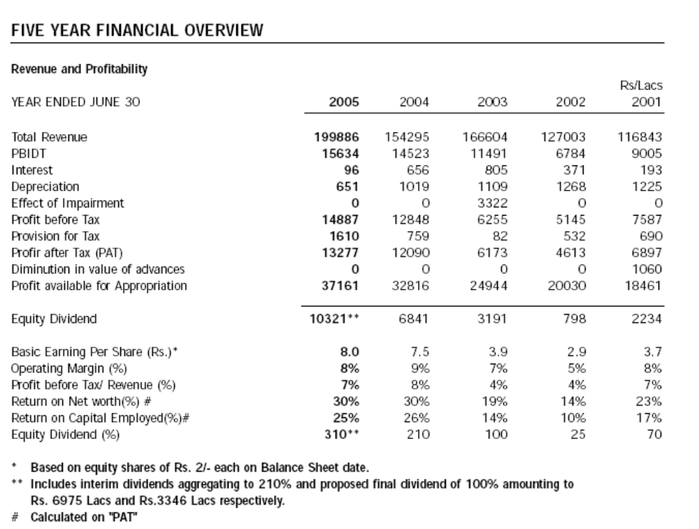
2006 2005 2004 2003 2002

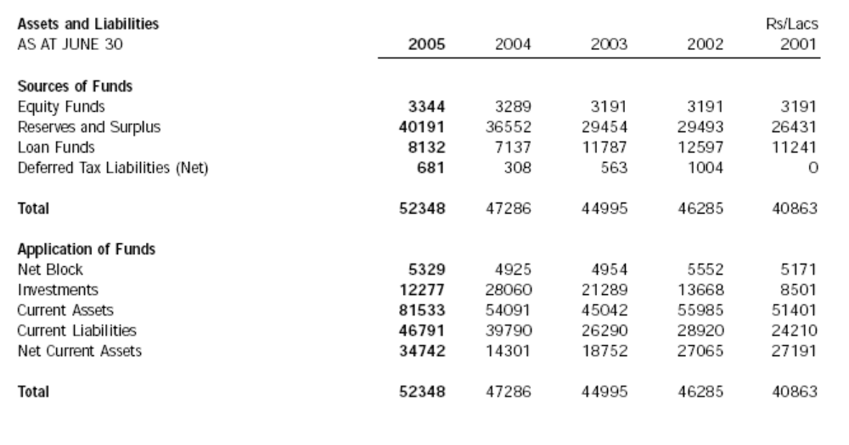
2006 2005 2004 2003 2002

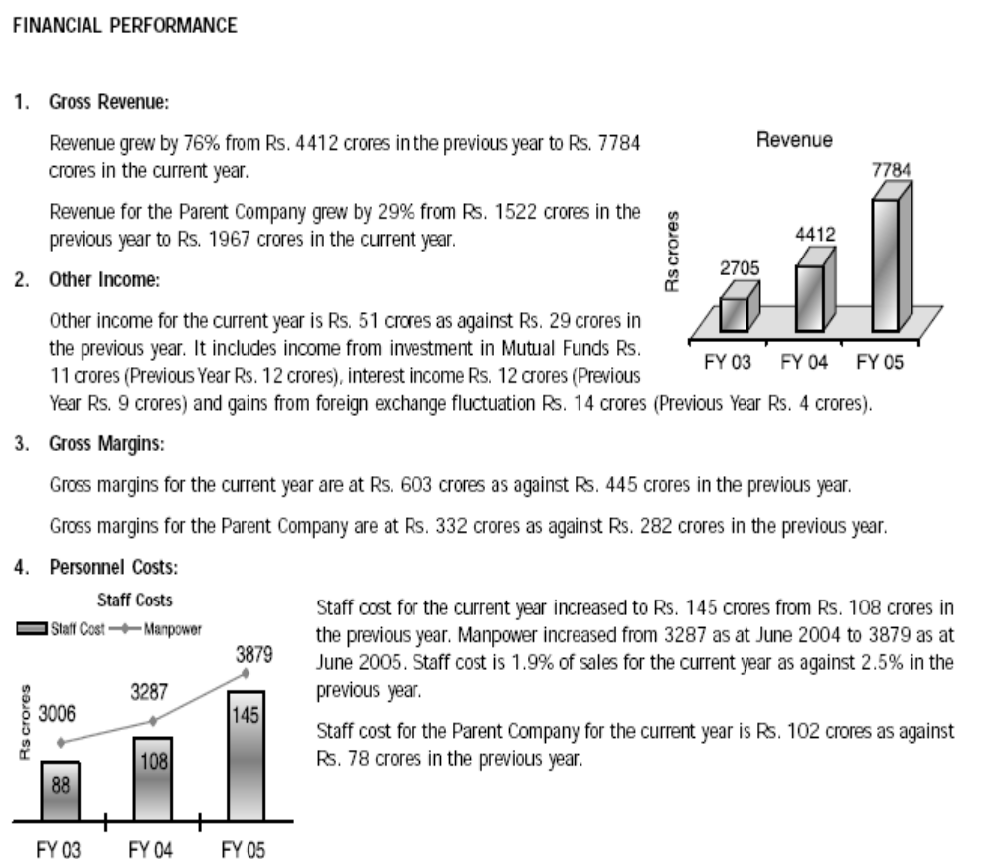

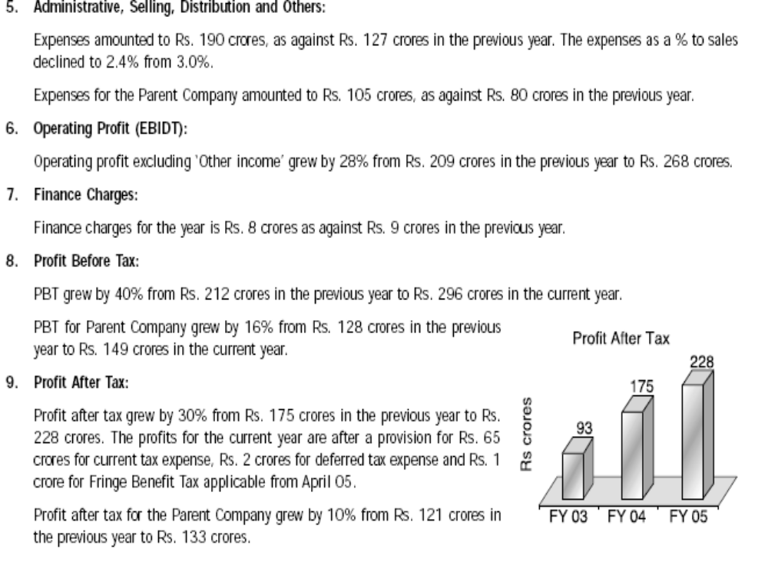
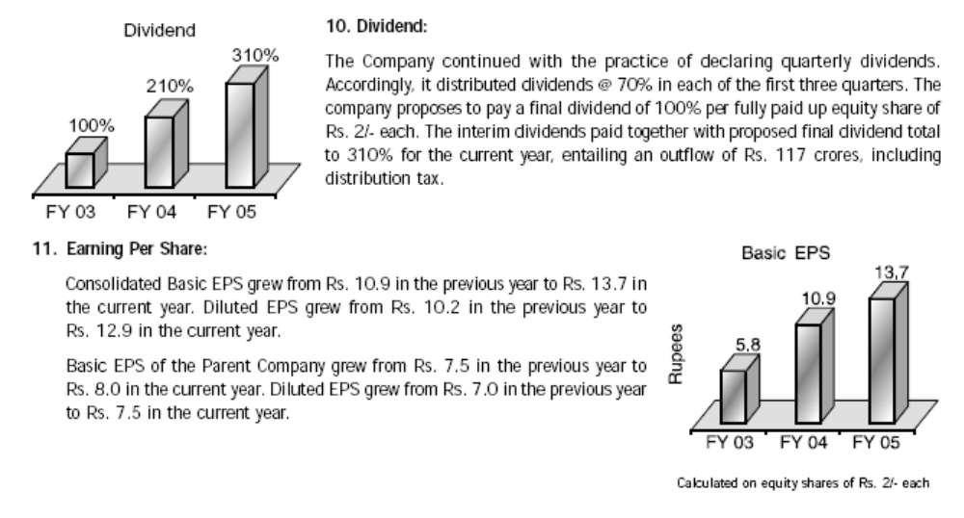

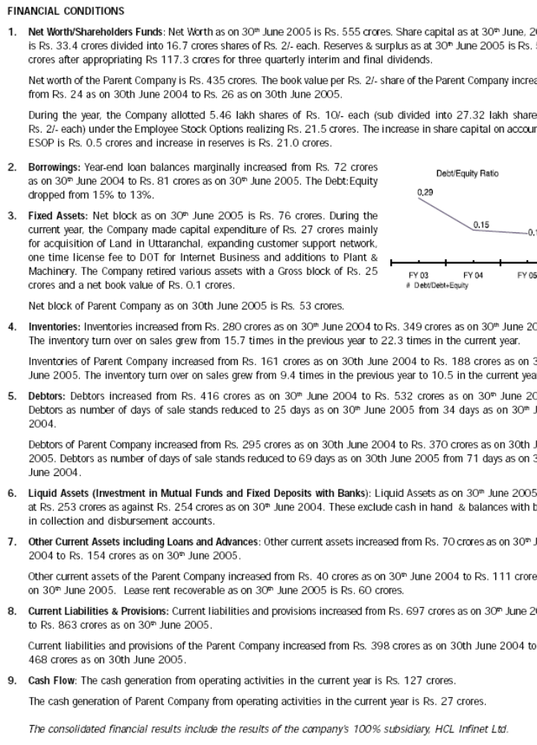

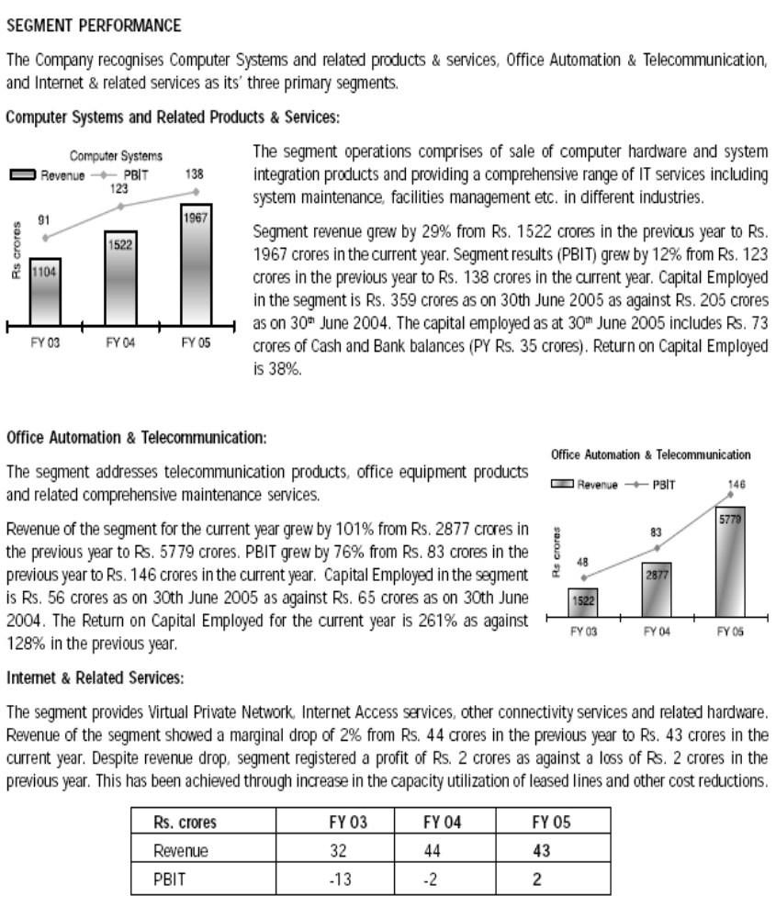
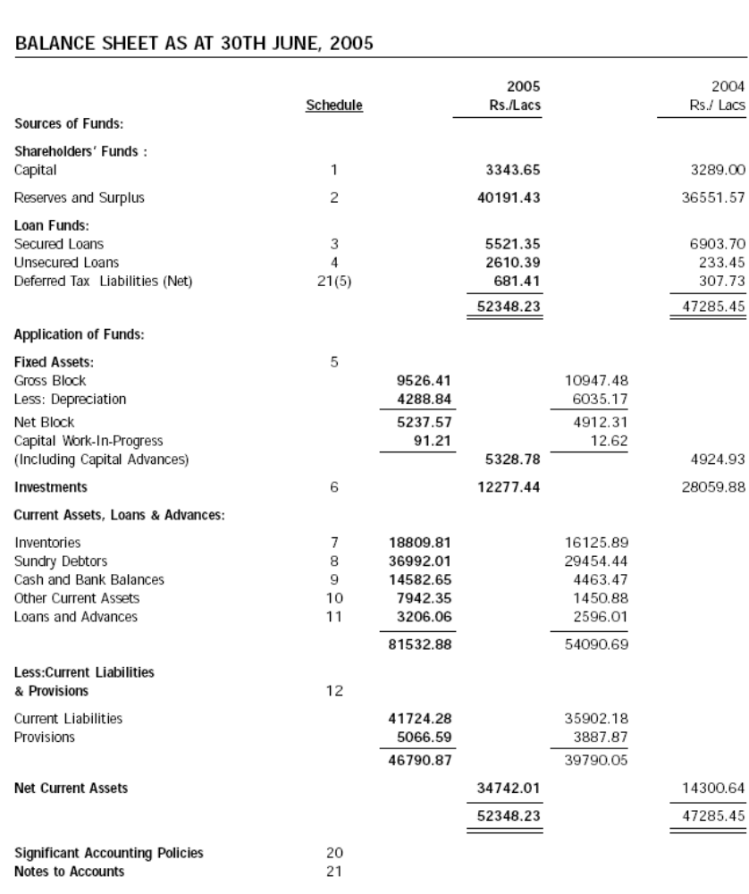
Balance Sheet for the Year Ended as on 31st march 2006

2006 2005

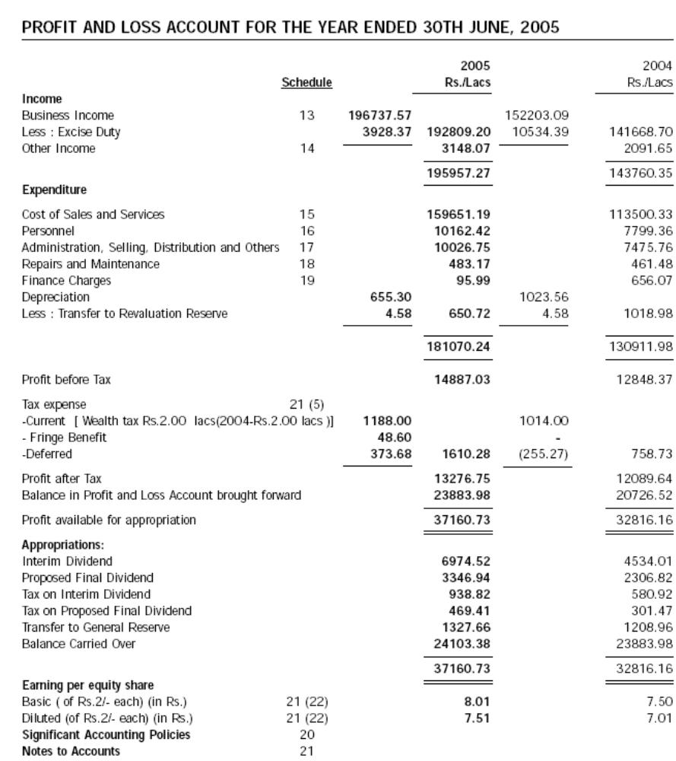
Profit and Loss Account for the Year Ended as on 31st march 2006
2006 2005
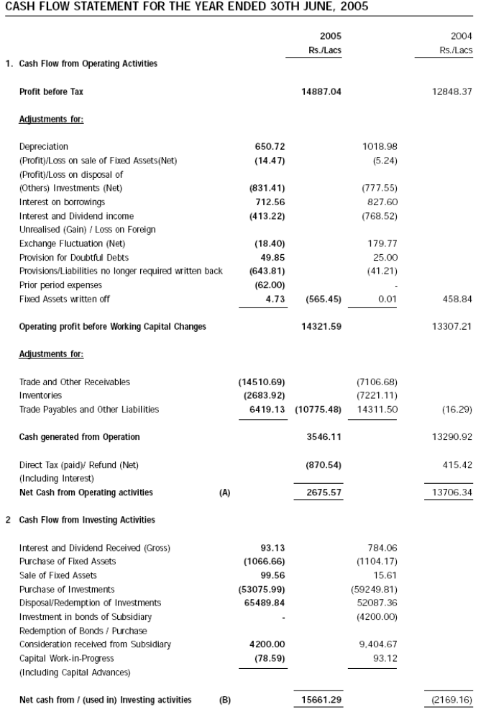
CASH FLOW STATEMENT FOR THE YEAR ENDED 31ST MARCH, 2006

2006 2005
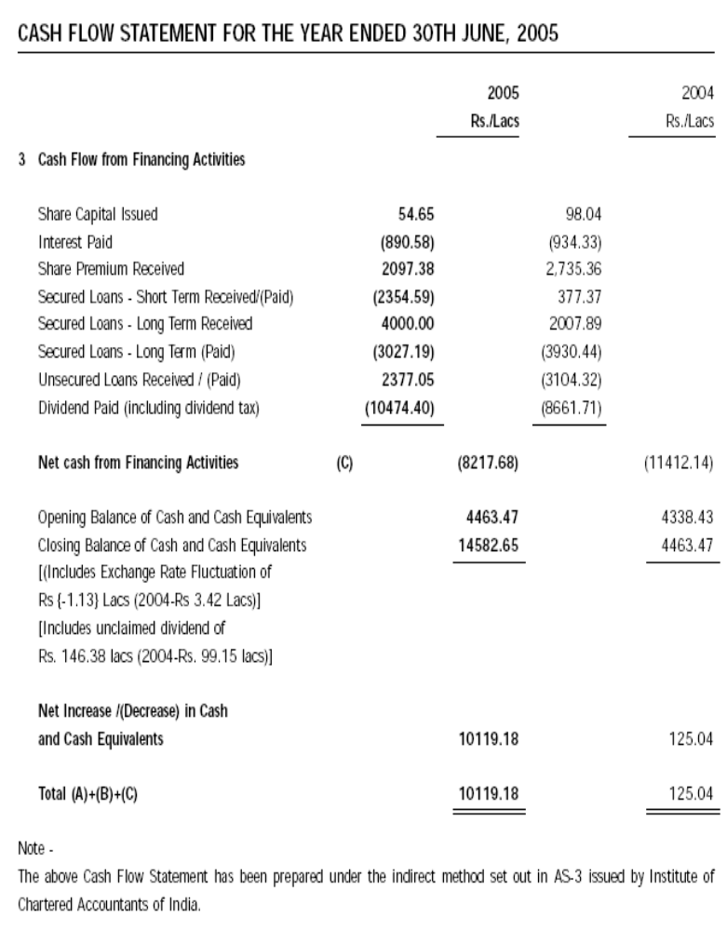
CASH FLOW STATEMENT FOR THE YEAR ENDED 31ST MARCH, 2006

2006 2005

WORKING CAPITAL POSITION

 | 2006 | 2005 | 2004 | 2003
CURRENT ASSETS | 81533 | 54091 | 45042 | 55985
NET FIXED ASSETS | 5329 | 4925 | 4954 | 5552
TOTAL ASSETS | 99139 | 87076 | 71285 | 75205
CA / TA | 82.24 | 62.11 | 63.18 | 74.44
NET CURRENT ASSETS | 34742 | 14301 | 18752 | 27065

The 143 percent increase in Net Current Assets is due to the fact that there has been an increase in the Current Assets by 50.73% and increase in Current Liability has been only 17.50% over that of the previous year. The firm’s level of liquidity being high we need a check on whether it affects the return on assets. Now there is a substantial increase in the current assets to total assets. This could be less profitable on the assumption that current assets generate lesser return as compared with return on fixed assets.

RISK-RETURN ANALYSIS
 | 2006 | 2005 | 2004
SALES | 199886 | 154295 | 166604
EBIT | 15634 | 14523 | 11491
RETURN ON INVESTMENT (%) | 39 | 75.5

In case instead of Net Current assets and net block if total assets had been used in computation of ROI then

TOTAL ASSETS | 52348 | 47286
RETURN ON INVESTMENT (%) | 60.36 | 30.3

CURRENT ASSET SCENARIO

COMPONENT | 2006 | 2005
INVENTORY | 23.07 | 29.81
SUNDRY DEBTORS | 45.37 | 54.45
CASH AND BANK ASSETS | 17.88 | 8.25
OTHER CURRENT ASSETS | 9.74 | 2.68
LOAN AND ADVANCES | 3.93 | 4.79

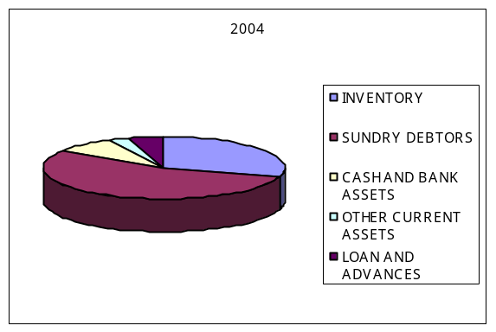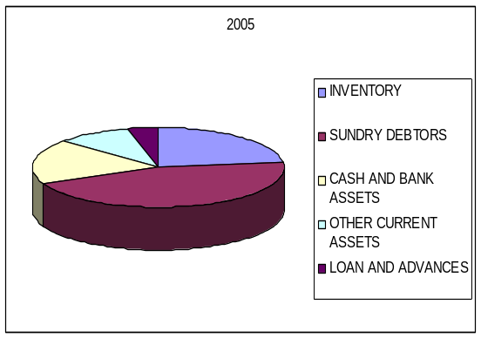

While there has been increase in the value of all components of the Current Assets the proportion of inventory debtors and loans and advances to the current assets have declined. Whether this proportionatedecline to current assets is as a result of reduced lead time and better operating cycle? This might directly implicate better receivables management and inventory control.

INVENTORY MANAGEMENT
COMPOSITION | 2006 | 2005 | % INC
RAW MATERIAL | 41.43 | 38 | 27.2
STORES AND SPARES | 15.88 | 16.25 | 13.94
FINISHED GOODS | 38.51 | 40.34 | 11.36
WORK IN PROGRESS | 4.16 | 5.4 | -10.03

% INC
-15
-10
-5
0
5
10
15
20
25
30
RAW
MATERIAL
STORES
AND
SPARES
FINISHED
GOODS
WORK IN
PROGRESS
INVENTORY
%INCREASE
% INC

The increasing component of raw materials in inventory is due to the fact that the company has gone for bulk purchases and has increased consumption due to a fall in prices and reduced margins for the year.
To the question as to whether the increasing costs in inventory are justified by the returns from it the answer could be found in the HCL retail expansion. They are more into it than earlier and at present more than 650 retail outlets branded with HCL signages and more are in the pipeline. This also ensures availability of products to meet the increasing sales.

A negative growth in WIP could be because of
1) Better and efficient conversion of raw materials to finished goods i.e. the time taken to convert raw materials after procurement to the end product is very minimal.
2) This also is due to capacity being not utilized at the optimum which should mean that more of goods are stagnant at the operations. But this is not the scenario witnessed here as could be easily seen from the increased utilization of plant capacity.

The 69.5% rise in value is primarily due to the increase in the consumption of raw materials in processors. This shifting value has to be traced back to the sales of computers / micro processor based systems i.e. whether sales justify this increase.
The sales in value have increased by 30% (42584.75/142148.56). this is a marked increase from the previous year where despite the increase in the value of raw materials consumed there was a decline in the value of sales.
The current ratio after a decline in 2004 has increased which means an increase in liquidity and solvency position of the firm. This reaffirms what had been stated earlier firms current assets are at an all time high. This they might have done to cover the risk involved in their expanding operations. The present ratio of 1.742:1 could be claimed to be optimal as the desired ratio of the company is about is about 1.33:1. but how far has been the ratio successful in indicating the relative liquidity of current assets and liabilities have not been answered.

The value of imported and indigenous raw material consumed give a clear picture that if there is a change in the EXIM policy of the government it is bound to affect the company adversely as more than70%of their consumption is from imports. But this is a scenario witnessed in the industry as a whole and though HCL is into expanding its operations to Uttaranchal it is also bound to be affected by a change in the import duty structure.

CASH MANAGEMENT

In cash management the collect float taken for the cheques to be realized into cash is irrelevant and non- interfering here because banks such as Standard Chartered, HDFC and CITI who give credit on the basis of these cheques after charging a very small amount. Even otherwise the time taken for the cheques to be processed is instantaneous. Their Cash Management System is quite efficient.

WORKING CAPITAL & SHORT TERM FINANCING
NAME OF THE BANK | FUND BASED | NON FUND BASED
STATE BANK OF INDIA | 3600 | 13000
ICICI BANK | 1282 | 4790
HDFC BANK | 1200 | 6025
STANDARD CHARTERED BANK | 1200 | 4000
STATE BANK OF SAURASHTRA | 715 | 4000
STATE BANK OF PATIALA | 1300 | 3350
CANARA BANK | 1203 | 2335
SOCIETE GENERALE | 1000 | 1000
TOTAL | 11500 | 38500

The consortium of banks provide a fund based limit of 115 crores which comprises of cash credit and working capital demand loans and non fund based limits which has bank guarantee and letter of credit subject to a limit of 385 crores.Any issue of the commercial paper in the part of the firm leads to a decline in the limit of fund based limits. Currently the firm having issued commercial papers worth rs30crores for the year 2006 has asked the lead bank to deduct the fund based limit from 115 crores to 85 crores.

In terms of desirability the commercial papers are cheaper and advantageous to the firm compared to the consortium financing. But the firm depends on both and for working capital financing is depended on the banks for funds such as working capital demand loans and cash credits.

SECURED LOANS | 2006 | 2005 | 2004
SHORT TERM | 4991.28 | 6903.7 | 4987.52
LONG TERM | 530.07 | 0 | 3461.36
TOTAL | 5521.35 | 6903.7 | 8448.88
% SHORT TERM | 90.4 | 100 | 59.03
UNSECURED LOANS | 2006 | 2005 | 2004
SHORT TERM | 2593.39 | 63.94 | 76.84
LONG TERM | 17 | 169.51 | 3261.42
TOTAL | 2610.39 | 233.45 | 3338.26
% SHORT TERM | 99.348 | 27.38 | 2.3

The preference of short term financing to long term as such is not the part of any policy employed by the firm but due to the reason that they were cheaper and the interest rates lower.

The other notable feature in HCL statements has been the growing dividend policy of the firm which has meant that the firm doesn’t have at its disposal too much cash in hand. That is the firm disburse as dividends profits which could have either been retained in the business for capital expenditure. But rather than investing more in plant and machine which they can at any point in time by adding on a additional line if need be they would like to optimize their utilization in fixed assets at present.

DIVIDEND POLICY

 | 2006 | 2005 | 2004
DIVIDEND PAID ( INCLUDIND CDT) | 11729.69 | 7723.22 | 3599.79
PROFIT AFTER TAX | 13276.75 | 12089.64 | 6172.89
DIVIDEND PAY-OUT RATIO | 88.34 | 63.88 | 58.31

The dividend pay-out ratio is increasing tremendously over the years. Dividends imply outflow of cash and lowers future growth. However a high dividend pay-out ratio may lead to a rise in prices of shares.

LOANS AND ADVANCES
SECURED LOANS
 | 2006 | 2005 | 2004
TOTAL BORROWINGS | 5521.35 | 6903.7 | 8448.88
SHORT-TERM | 4991.28 | 6903.7 | 4987.52
PERCENTAGE SHORT-TERM | 90 | 100 | 59

UN-SECURED LOANS
 | 2006 | 2005 | 2004
TOTAL BORROWINGS | 2610.39 | 233.45 | 3338.26
SHORT-TERM | 2593.39 | 63.94 | 76.84
PERCENTAGE SHORT-TERM | 99.36 | 27.39 | 2.3

The company is going for more and more shore-term financing, could be because of the fact that it is considered as a cheaper source than long-term financing.

CHAPTER – 5

CONCLUSION

- Sales are decreasing during the year 2006-07. Hence profitability has declined over this time period

- Due to increase in the time period for the realization of debtors, cash and bank balance has decreased.

- Stock turn over ratio is decreasing, it shows that capital is blocked into the inventory.

- Fixed asset turnover ratio has decreased this year, which shows that assets have not been used efficiently as they had been used in the previous year.

All the above ratios show a decreased or unfavorable situation because of the work of entire replacement of coolant channel, due to which the production process had been stopped.

RECOMMENDATION

Loans & Advances

Special efforts should be made to analyze loans & advances, which are between 35% to 56% of current assets. This can be classified between production / operation relation related and non-production / operation related. No production related cases might be financed from other sources like debenture etc. and treated separately.

Inventory

Inventory should be reviewed constantly to identify show / dead / obsolete item and then disposed until 2000-01 level is again achieved.

Optimum level should be revised periodically, keeping in view, distance of suppliers, production lead time of supplier, transport problem if any and reliability of suppliers. This will help to avoid obsolesce and dead inventory.

Debtors
A study may be conducted if required by experts to pinpoint reason behind HCL INFOSYSTEM LTD. high correction period of 95 days in 2004-05 against 50 days of TCS It is due to quality of products, quality of customer, the segment of customers marketing effort, distribution pattern or other reasons.

Creditors

Though high payout days may be apparently beneficial for the company. It has it very heavy long term cost like high interest cost, bad credit ratings and shyness of good quality / standard suppliers.

Cash & Bank

This is the most liquid element in current asset and target shall be fixed most cautiously. Too low a figure of 4.4% of total current assets of HCL INFOSYSTEM LTD. in 2003-04 as against 15.5% of TCS may be apparently too good to look at, but this may be lead to payment crisis at various sorts.

Ratios

The company should try to improve its current situation. The ratios, which are taken in this research to evaluate the company’s position, are Current ratio, Quick ratio and Activity ratio. These ratios show the actual position of the company. The Quick ratio is declining since 2001-02 till now. There is a drastic declining in the working capital turnover ratio. This ratio goes to –ve position in current year compared to previous. The Debts collection period is 359 days for Exporters. This shows the poor collection policy. The current ratio is 1.02 in 2005-06, which is not upto the ideal ratio. This shows that the current assets are equal to the current liabilities. Not satisfactory.

CHAPTER – 6
BIBLIOGRAPHY

Books / Journals
    - Khan and Jain Financial Management.
    - ICAI’s Module.

Magazines & Newspapers
    - Business World
    - Business Today
    - The Economic Times
    - The Hindu Business Standard Lines
    - The Times of India
Referred Sites
  - www.financehcl.com
  - www.hcleconomic.org
  - www.google.com
  - www.hclinfosystems.com

